* Help info about arp command

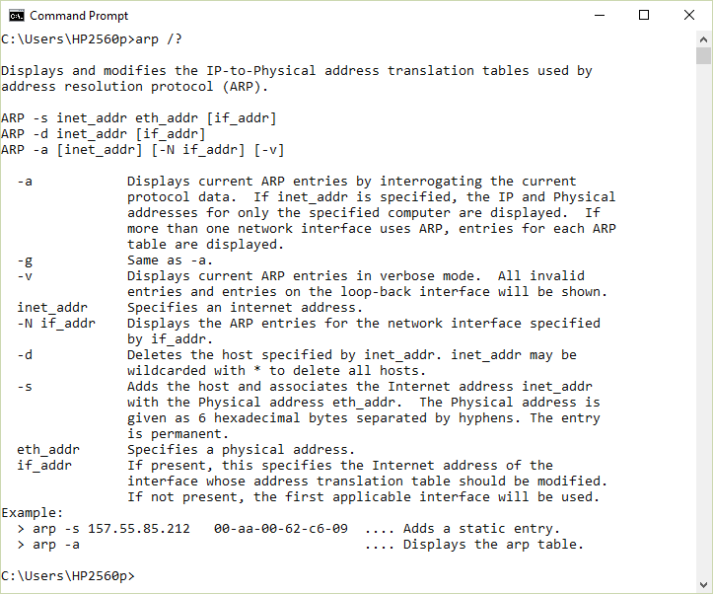

* Display ARP-table

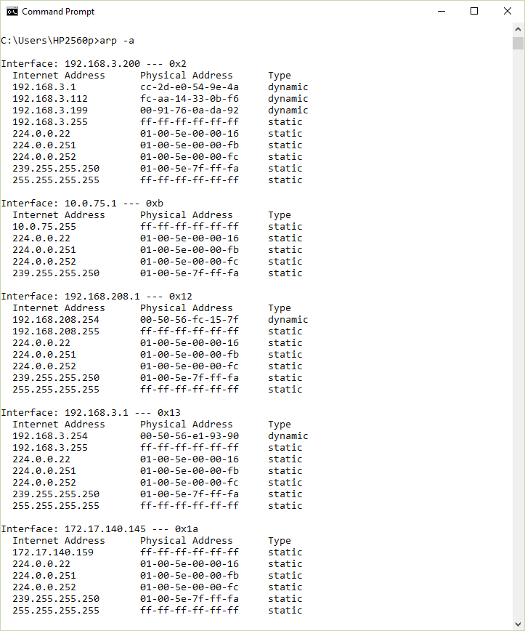

* Pick network interface

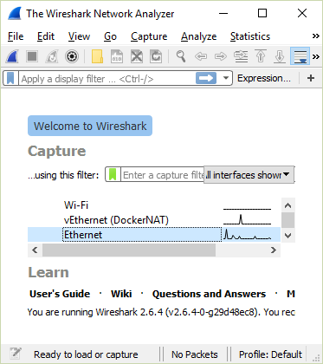

* Clean ARP-table

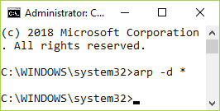

* Check ARP-table is empty, haha not  
  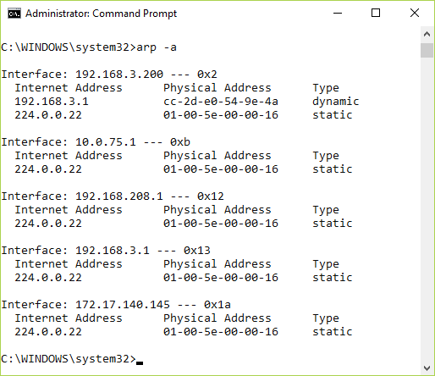
* Ping computer in local network  
  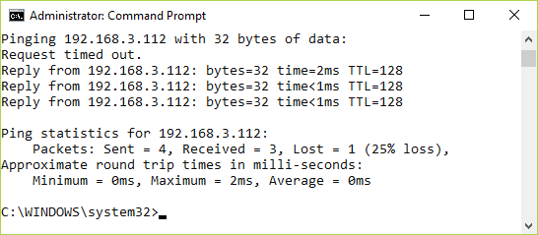
* Stop capturing packets (Wireshark)

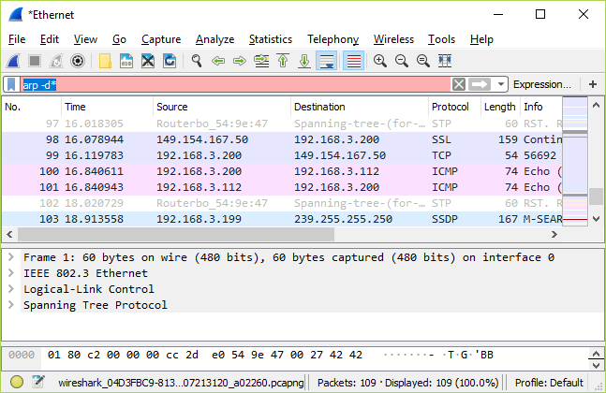

* Filtered ICMP and ARP only

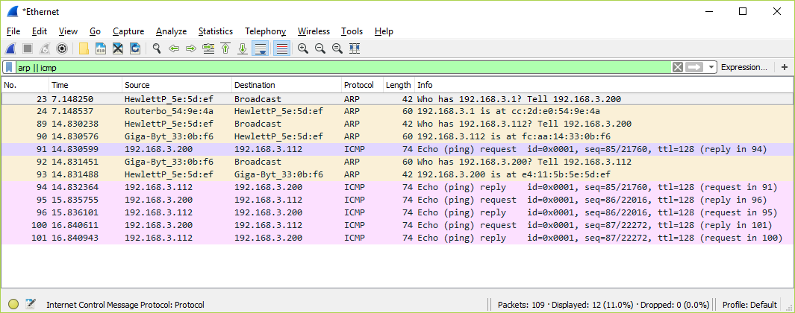

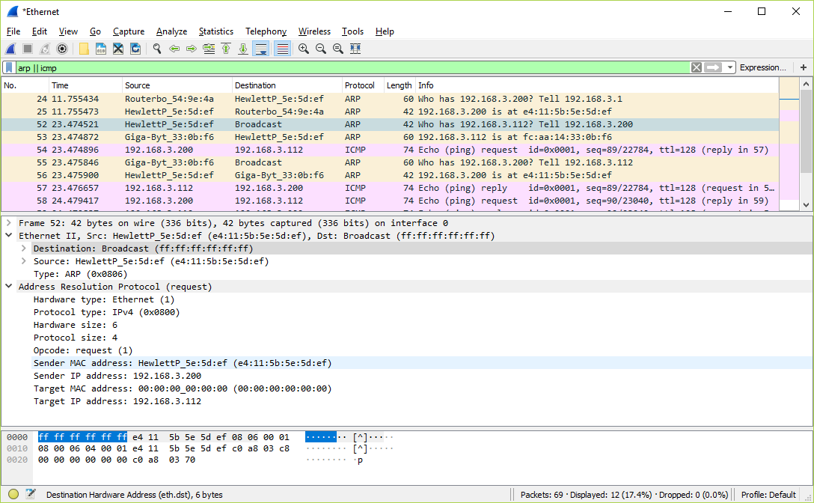

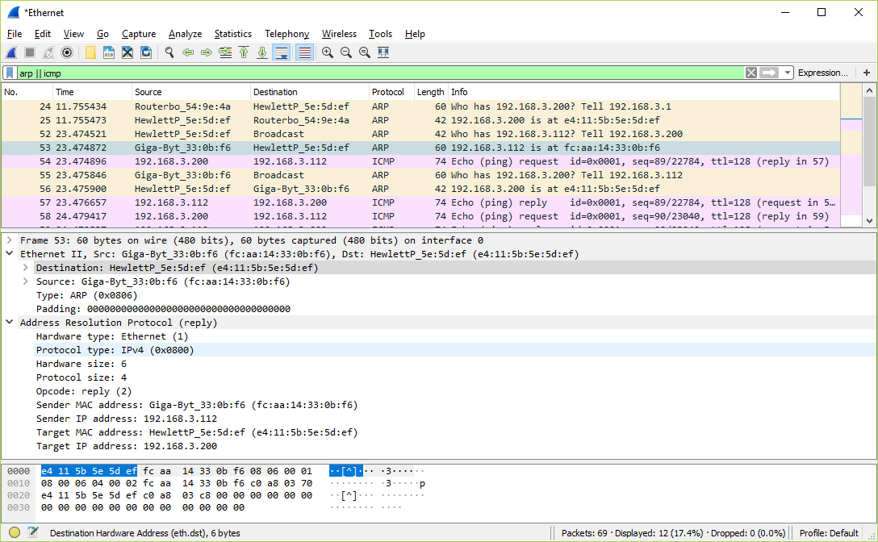

* ARP dialog sketch
* ARP-table  
  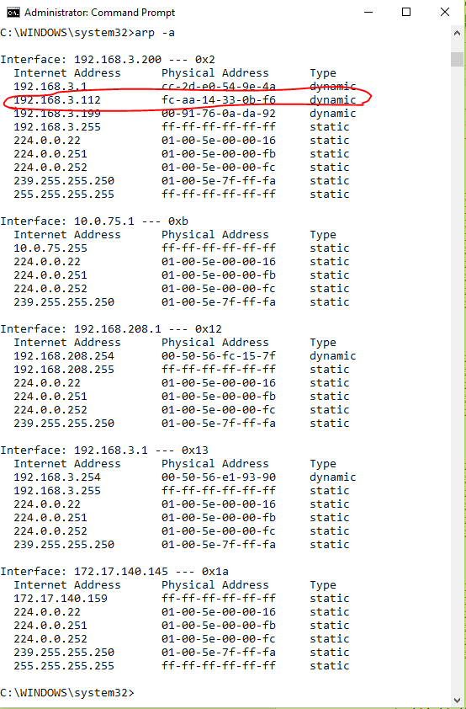
* 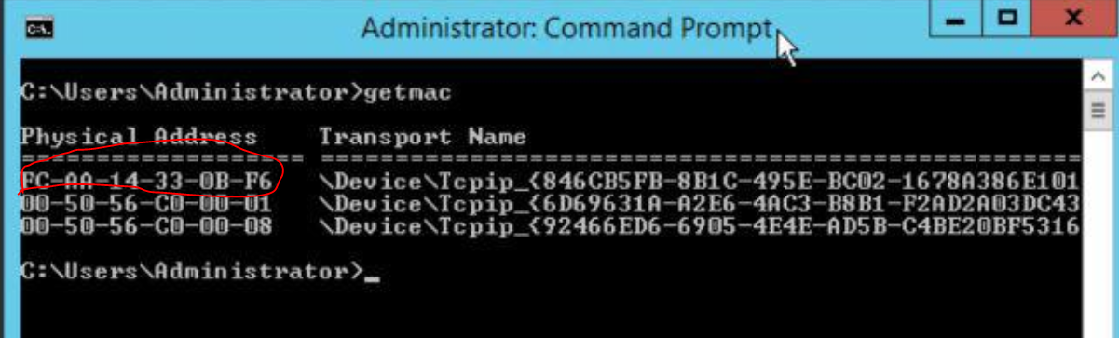

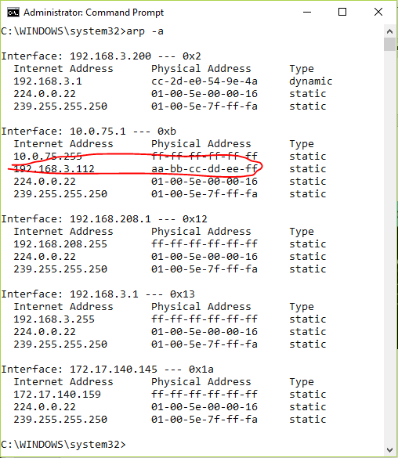

* 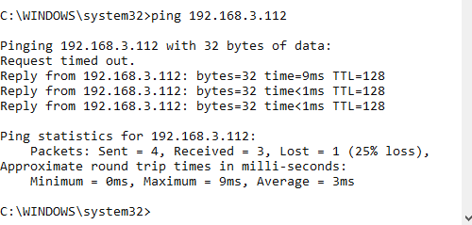

-removed address  
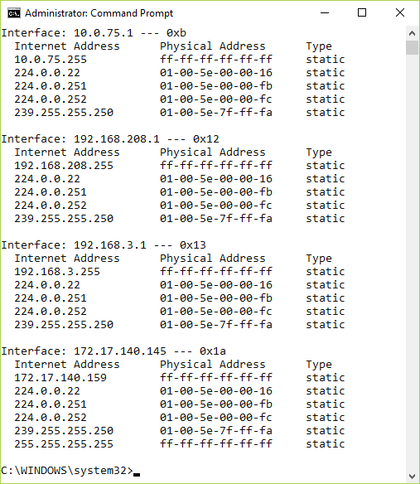  
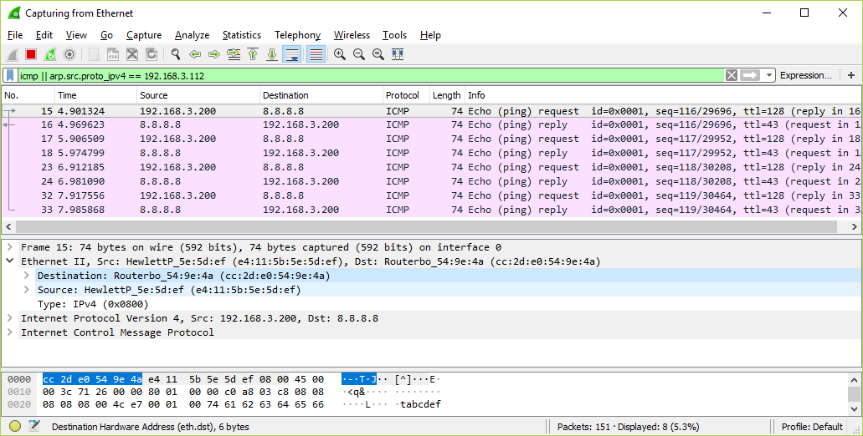

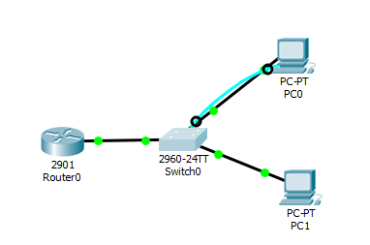

Pc-1

FastEthernet0 Connection:(default port)

Connection-specific DNS Suffix..:

Physical Address................: 0001.43EA.3C01

Link-local IPv6 Address.........: FE80::201:43FF:FEEA:3C01

IP Address......................: 192.168.3.3

Subnet Mask.....................: 255.255.255.0

Default Gateway.................: 192.168.3.1

DNS Servers.....................: 0.0.0.0

DHCP Servers....................: 0.0.0.0

DHCPv6 Client DUID..............: 00-01-00-01-04-B4-D6-CD-00-01-43-EA-3C-01

PC-2

FastEthernet0 Connection:(default port)

Connection-specific DNS Suffix..:

Physical Address................: 00E0.F998.2C67

Link-local IPv6 Address.........: FE80::2E0:F9FF:FE98:2C67

IP Address......................: 192.168.3.4

Subnet Mask.....................: 255.255.255.0

Default Gateway.................: 192.168.3.1

DNS Servers.....................: 0.0.0.0

DHCP Servers....................: 0.0.0.0

DHCPv6 Client DUID..............: 00-01-00-01-E0-5C-E2-26-00-E0-F9-98-2C-67

Switch

Switch#show interface vlan1

Vlan1 is up, line protocol is up

Hardware is CPU Interface, address is 00d0.ffd5.59c4 (bia 00d0.ffd5.59c4)

Internet address is 192.168.3.2/24

MTU 1500 bytes, BW 100000 Kbit, DLY 1000000 usec,

reliability 255/255, txload 1/255, rxload 1/255

Encapsulation ARPA, loopback not set

ARP type: ARPA, ARP Timeout 04:00:00

Last input 21:40:21, output never, output hang never

Last clearing of "show interface" counters never

Input queue: 0/75/0/0 (size/max/drops/flushes); Total output drops: 0

Queueing strategy: fifo

Output queue: 0/40 (size/max)

5 minute input rate 0 bits/sec, 0 packets/sec

5 minute output rate 0 bits/sec, 0 packets/sec

1682 packets input, 530955 bytes, 0 no buffer

Received 0 broadcasts (0 IP multicast)

0 runts, 0 giants, 0 throttles

0 input errors, 0 CRC, 0 frame, 0 overrun, 0 ignored

563859 packets output, 0 bytes, 0 underruns

0 output errors, 23 interface resets

0 output buffer failures, 0 output buffers swapped out

Router

GigabitEthernet0/0 is up, line protocol is up (connected)

Hardware is CN Gigabit Ethernet, address is 0001.6344.3d01 (bia 0001.6344.3d01)

Internet address is 192.168.3.1/24

MTU 1500 bytes, BW 1000000 Kbit, DLY 100 usec,

reliability 255/255, txload 1/255, rxload 1/255

Encapsulation ARPA, loopback not set

Keepalive set (10 sec)

Full-duplex, 100Mb/s, media type is RJ45

output flow-control is unsupported, input flow-control is unsupported

ARP type: ARPA, ARP Timeout 04:00:00,

Last input 00:00:08, output 00:00:05, output hang never

Last clearing of "show interface" counters never

Input queue: 0/75/0 (size/max/drops); Total output drops: 0

Queueing strategy: fifo

Output queue :0/40 (size/max)

5 minute input rate 0 bits/sec, 0 packets/sec

5 minute output rate 0 bits/sec, 0 packets/sec

4 packets input, 188 bytes, 0 no buffer

Received 4 broadcasts, 0 runts, 0 giants, 0 throttles

0 input errors, 0 CRC, 0 frame, 0 overrun, 0 ignored, 0 abort

0 watchdog, 1017 multicast, 0 pause input

0 input packets with dribble condition detected

0 packets output, 0 bytes, 0 underruns

0 output errors, 0 collisions, 1 interface resets

0 unknown protocol drops

0 babbles, 0 late collision, 0 deferred

0 lost carrier, 0 no carrier

0 output buffer failures, 0 output buffers swapped out

Pinging 192.168.3.2 with 32 bytes of data:

Request timed out.

Reply from 192.168.3.2: bytes=32 time<1ms TTL=255

Reply from 192.168.3.2: bytes=32 time=1ms TTL=255

Reply from 192.168.3.2: bytes=32 time<1ms TTL=255

Ping statistics for 192.168.3.2:

Packets: Sent = 4, Received = 3, Lost = 1 (25% loss),

Approximate round trip times in milli-seconds:

Minimum = 0ms, Maximum = 1ms, Average = 0ms

Pinging 192.168.3.1 with 32 bytes of data:

Reply from 192.168.3.1: bytes=32 time<1ms TTL=255

Reply from 192.168.3.1: bytes=32 time<1ms TTL=255

Reply from 192.168.3.1: bytes=32 time<1ms TTL=255

Reply from 192.168.3.1: bytes=32 time=1ms TTL=255

Ping statistics for 192.168.3.1:

Packets: Sent = 4, Received = 4, Lost = 0 (0% loss),

Approximate round trip times in milli-seconds:

Minimum = 0ms, Maximum = 1ms, Average = 0ms

Pinging 192.168.3.4 with 32 bytes of data:

Reply from 192.168.3.4: bytes=32 time<1ms TTL=128

Reply from 192.168.3.4: bytes=32 time<1ms TTL=128

Reply from 192.168.3.4: bytes=32 time=1ms TTL=128

Reply from 192.168.3.4: bytes=32 time=1ms TTL=128

Ping statistics for 192.168.3.4:

Packets: Sent = 4, Received = 4, Lost = 0 (0% loss),

Approximate round trip times in milli-seconds:

Minimum = 0ms, Maximum = 1ms, Average = 0ms

SWITCH  
Mac Address Table

-------------------------------------------

Vlan Mac Address Type Ports

---- ----------- -------- -----

1 0001.43ea.3c01 DYNAMIC Fa0/2

1 0001.6344.3d01 DYNAMIC Fa0/1

1 00e0.f998.2c67 DYNAMIC Fa0/3

Switch>show arp

Protocol Address Age (min) Hardware Addr Type Interface

Internet 192.168.3.2 - 00D0.FFD5.59C4 ARPA Vlan1

Internet 192.168.3.3 5 0001.43EA.3C01 ARPA Vlan1

ROUTER

Mac Address Table

-------------------------------------------

Vlan Mac Address Type Ports

---- ----------- -------- -----

Router#show arp

Protocol Address Age (min) Hardware Addr Type Interface

Internet 192.168.3.1 - 0001.6344.3D01 ARPA GigabitEthernet0/0

Internet 192.168.3.3 6 0001.43EA.3C01 ARPA GigabitEthernet0/0